Oops part 2 constructors and destructors:

Constructors in C++:
1.Constructors are the methods whose name is same as the class with no return value.
2.They are invoked automatically just after the object creation(giving it a physical memory). We cannot call a constructor more than once for a single object. It is called only when the object is created
3. It constructs the values i.e initializes the member variables.
4. If we do not specify a constructor, C++ compiler generates a default constructor for object (expects no parameters and has an empty body).

Ex1:
class student{
public:
int rollno;
string name;
student(int rollno, string name)
{
this->rollno = rollno;
this->name = name;
}
void print()
{
cout << rollno << " " << name << "\n";
}
};
int main()
{
student a(2, "harsha");
a.print();
}
Outputy:
2,harsha.

Ex2: defining outside the class
class student{
public:
int rollno;
string name;

student(int, string); //function declaration
void print()
{
cout << rollno << " " << name << "\n";
}
};
student :: student(int rollno, string name)
{
this->rollno = rollno;
this->name = name;
}
int main()
{
student a(2, "harsha");
a.print();
}

5. In c++, address of the constructers cannot be refered. This below example is not possible.
#include <iostream>
using namespace std;
class A
{
public:
A(int x)
{
cout << "parameterized constructor";
}
void fun()
{
(*this)(5);
}
};
int main()
{
A a;
a.fun();
}

6. Constructors in multilevel inheritance.
class A{
public:
A( )
{
cout << "A constructor called" << "\n";
}
};
class B: public A{
public:
//if we wrote parameters inside the bracket then it will be an error
B( )
{
cout << "B constructor called" << "\n";
}
};
class C: public B{
public:
C( )
{
cout << "C constructor called";
}
};
int main()
{
C objc;
}
Output:
A constructor called
B constructor called
C constructor called

A constructor will be called after creating the corresponding physical object indicating that an object is created. So now we want to create a “C” object . Creation of “C” object involves creating its own variables and parent object. Here parent object is “B”. Similarly creation of “B” object involves creating its own variables and its parent object “A”.
So creation of C object involves creation of B and creation of B involves creation of A. So order of objects creation is A, B, C. So output is like that.

7. Constructors in multiple inheritance.
Constructors of inherited classes are called in the same order in which they are inherited.

class A{
public:
A()
{
cout << "constructor A called" << "\n";
}
};
class B{
public:
B()
{
cout << "constructor B called" << "\n";
}
};
//note the order
class C : public A, public B{
public:
C()
{
cout << "constructor C called" << "\n";
}
};
int main()
{
C objc;
}
Output:
constructor A called
constructor B called
constructor C called

8.constructors in multilevel+multiple.
class A{
public:
A()
{
cout << "A constructor called" << "\n";
}
};
class B: public A{
public:
B()
{
cout << "B constructor called" << "\n";
}
};
class C{
public:
C()
{
cout << "C constructor called" << "\n";
}
};
class D: public B, public C{
public:
D()
{
cout << "D constructor called";
}
};
int main()
{
D objd;
}
Output:
A constructor called
B constructor called
C constructor called
D constructor called

9.Constructors in hierarchical+multilevel+multiple
(Hybrid)
class A{
public:
A()
{
cout << "A constructor called" << "\n";
}
};
class B: public A{
public:
B()
{
cout << "B constructor called" << "\n";
}
};
class D: public B{
public:
D()
{
cout << "D constructor called" << "\n";
}
};
class C: public A{
public:
C()
{
cout << "C constructor called" << "\n";
}
};
class E: public D, public C{
public:
E()
{
cout << "E constructor called" << "\n";
}
};
int main()
{
E obje;
}
Output :
A constructor called
B constructor called
D constructor called
A constructor called
C constructor called
E constructor called

10. General example:
class A{
public:
A()
{
cout << "constructor A" << "\n";
}
};
class B : public A{
public:
B()
{
cout << "constructor B" << "\n";
}
};
class C : public B{
public:
C()
{
cout << "constructor C" << "\n";
}
A a;
};
class D : public C{
public:
D()
{
cout << "constructor D" << "\n";
}
};
int main()
{
D objd;
}
Output:
constructor A
constructor B
constructor A
constructor C
constructor D

For creating C object, 1st parent object created and then chetha(data member “a”) created and then constructor call

Default constructor:
Constructors with no arguments.
If the default constructor is not defined in the code then compiler generates a default constructor implicitly.
Will there be any code inserted by the compiler to the user implemented default constructor behind the scenes?
The compiler will implicitly declare the default constructor if not provided by the programmer, will define it when in need. The compiler-defined default constructor is required to do certain initialization of class internals. Its will not touch the data members or plain old data types (aggregates like an array, structures, etc…). However, the compiler generates code for the default constructor based on the situation.

Parameterised constructor: (helps in function overloading)
Note: When the parameterized constructor is defined and no default constructor is defined explicitly, then default constructor cannot be called and it leads to error to invoke default constructor.
class A{
public:
A(int a, int b)
{
cout << a+b << "\n";
}
};
int main()
{
A;
}
Output: error: no matching function for call to ‘A::A()’
If A(5, 10) is there instead of A then it will not be an error.
Normally, if you don’t define any constructor, the compiler automatically generates a default constructor for the
class. Once you define a constructor with parameters, the compiler does not generate a default constructor automatically. This is because the compiler assumes you may have a specific design in mind and won’t create one unless explicitly defined.
How to Fix It?? - Add a default constructor explicitly.

Copy constructor:
1.a constructor which creates an object by initializing it with an object of the same class, which has been created previously.
2.It is also called member-wise initialization because the copy constructor initializes one object with the existing object, both belonging to the same class on a member-by-member copy basis.
Ex: Sample(const Sample &t)
{
this->id = t.id;
}

Ex:
class student{
public:
int rollno;
string name;

student(int rollno, string name){
this->rollno = rollno;
this->name = name;
}
student(const student &t){
rollno = t.rollno;
name = t.name;
}
void show()
{
cout << "Rollno = " << rollno << ", " << name << "\n";
}
};
int main()
{
student god(10, "sachin");
student king(god); // student king=god
king.show();
}

Note: student king(god); and student king=god;
is exactly the same

Default copy constructor:
An implicitly defined copy constructor will copy the members of an object in the same order that a constructor would members of the object.

class Sample{
public:
int* ptr;
Sample(int id)
{
this->ptr = new int;
*(this->ptr) = id;
}
void show()
{
cout << "id=" << *ptr;
}
};
int main()
{
Sample x(5);
Sample y=x;
y.show();
}
Output:
id=5

If we don’t define our own copy constructor, the C++ compiler creates a default copy constructor for each class
Default copy constr follows shallow copy
-> For non-pointer members, the values are copied directly.
-> For pointer members, only the pointer (address) is copied, not the data it points to

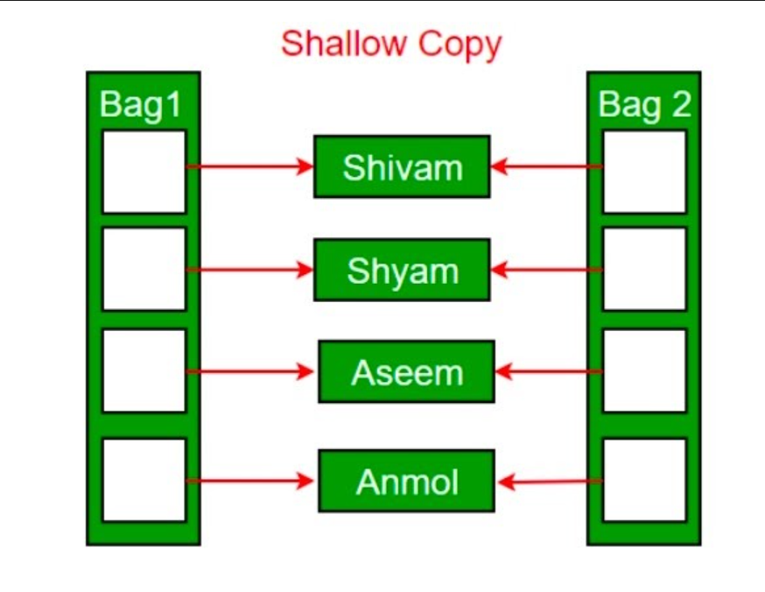
If your class contains pointers to heap memory, a shallow copy can lead to problems because both the original object and the copied object will point to the same memory location. If one object deletes or modifies this memory, it may cause dangling pointers

2. Whereas User defined copy constructor follows deep copy
we make sure that pointers (or references) of copied objects point to new copy of the dynamic resource allocated manually
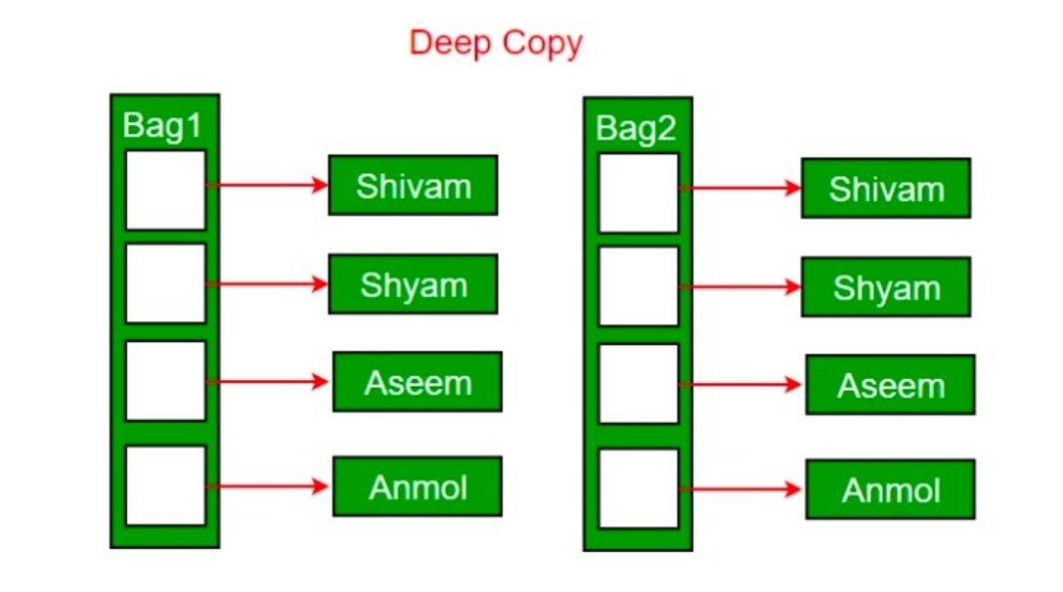

Shallow copy: In default copy constructor
class Sample{
public:
int* ptr;
Sample(int id)
{
this->ptr = new int;
*(this->ptr) = id;
}

void show()
{
cout << "id=" << *ptr << "\n";
}

void changevalue(int newid){
*ptr = newid;
}

void deleteval(){
delete ptr;
}
};
int main()
{
Sample x(5);
Sample y=x;
x.show();
y.show();
y.changevalue(25);
x.show();
y.show();
}
Output:
id = 5
id = 5
Id = 25
Id = 25
If i call y.deletevalue() or x.deletevalue() then both pointers points to same garbage value.

Deep copy:
class Sample{
public:
int* ptr;
Sample(int id)
{
this->ptr = new int;
*(this->ptr) = id;
}

Sample(const Sample &t){
this->ptr = new int;
*(this->ptr) = *(t.ptr);
}

void show()
{
cout << "id=" << *ptr << "\n";
}

void changevalue(int newid){
*ptr = newid;
}

void deleteval(){
delete ptr;
}
};
int main()
{
Sample x(5);
Sample y=x;
x.show();
y.show();
y.changevalue(25);
x.show();
y.show();
}

Output:
id=5
id=5
id=5
id=25

In C++, a copy constructor may be called in the following cases:
- When an object of the class is returned by value.
- When the compiler generates a temporary object.
- When an object of the class is passed (to a function) by value as an argument.
- When an object is constructed based on another object of the same class.

Copy constructor vs assignment operator:
Copy constructor is called when a new object is created and it is initialized using an existing object.
Assignment operator is called when an already initialized object is assigned a new value using existing object.

Why argument to a copy constructor must be passed as a reference?
If you pass the object by value in the copy constructor, it will result in a recursive call to the copy constructor itself. This happens because passing by value involves making a copy, and making a copy involves calling the copy constructor, leading to an infinite recursion. Using a reference avoids this recursion. So, we use reference of objects to avoid infinite calls.

Why argument to a copy constructor should be const?
One reason for passing const reference is, that we should use const in C++ wherever possible so that objects are not accidentally modified this can be a reason but there is also an other reason
It will be problematic in some cases like below
class Test
{
public:
Test(Test &t)
{ /* Copy data members from t*/}
Test()
{ /* Initialize data members */ }
};

Test fun()
{
Test t;
return t;
}

int main()
{
Test t2 = fun(); //copy constructor called
return 0;
}

Here fun() will return a temporary object and then we are calling copy constructor. So this temporary object is passed as an argument to the copy constructor.
compiler created temporary objects cannot be bound to non-const references
(lvalue references cannot be bound to rvalues, only const lvalue references can bound to rvalues)
So Use a const reference in the function parameter to increase the lifetime of the temporary object.

Can we make the copy constructor private?
Yes, a copy constructor can be made private. When we make a copy constructor private in a class, objects of that class become non-copyable. This is particularly useful when our class has pointers or dynamically allocated resources. In such situations, if we don’t handle the pointers carefully, its better to get a compile time error than getting a runtime errors like dangling pointers.
we can either write our own copy constructor or make a private copy constructor so that users get compiler errors rather than surprises at runtime.

Move constructor:
Before entering into move constructor, we have to go through some stuff:

Reference in C++: (&) - if time allows read complete article
When a variable is declared as a reference, it becomes an alternative name for an existing variable
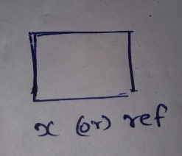
int main()
{
int x = 10;
int& ref = x;

ref = 20;
cout << "x = " << x << '\n';
cout << "ref = " << ref << '\n';

x = 30;
cout << "x = " << x << '\n';
cout << "ref = " << ref << '\n';
}

Output:
x=20
ref=20
x=30
ref=30

Once a reference is created, it cannot be later made to reference another object; it cannot be reset.
int main()
{
int x = 10, y=20;
int& ref = x;

cout << "x = " << x << '\n';
cout << "ref = " << ref << '\n';

ref = y; //here value inside y or ref is changed to 20... but its not like ref reseated to y
cout << "x = " << x << '\n';
cout << "ref = " << ref << '\n';

y=30; //So in spite of changing value of y, (x and ref) haven’t changed
cout << "x = " << x << '\n';
cout << "ref = " << ref << '\n';
}
Output:
x = 10
ref = 10
x = 20
ref = 20
x = 20
ref = 20

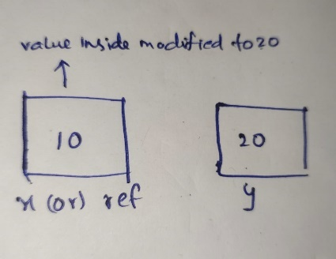

int fun(int& x) { return x; }
int main()
{
cout << fun(10);
return 0;
}

Output: compilation error
Its is senseless because It cannot refer to a constant value during initialization, but assigning a constant value is ok

Lvalues and rvalues:
a)lvalue (left value):
Represents an object that occupies some identifiable location in memory (i.e., it has an address).
It can appear on both the left-hand and right-hand sides of an assignment.
b)rvalue (right value):
Represents a temporary value that does not occupy a location in memory.
usually appearing on the right-hand side of an assignment

int y = 10; // y is an lvalue, 10 is an rvalue
int y = x; //both x and y are lvalues
int z = y + 5; // (y + 5) is an rvalue z is lvalue
int a = fun(100) fun(100) is an rvalue a is lvalue

lvalue reference and rvalue reference:
a)lvalue reference: (denoted with &)
These can only be bound to lvalues but not rvalues
int i = 10;
int &x = i; -> true
int &x = 10; ->false because lvalue reference cannot bound to r values

But const lvalue reference can be bound to rvalues.
const int &x = 10 ->true

int foo(int &i){
//return //
}
foo(10) ->false;
int a=10;
foo(a) ->true

b)rvalue referece: (denoted with &&)
Bind only to rvalues
int i=10
int &&rr = 10; -> true
int &&rr2 = foo(10); ->true

void f(int &lr) {cout << “lvaluef”; }
void f(int &&rr) {cout << “rvaluef”; }
main(){
int i=10;
f(i); //lvaluef
f(10); //rvaluef
f(move(i)); //rvaluef move() converts lvalue to rvalue
}

Copy constructor :
uses lvalue reference and copy data of old object to newly created object
Move constructor :
uses rvalue reference and transfer the ownership of the already existing object to the new object without making any copy of it. (so more efficient because copy operation wont involved)
our new object is now refering old object and old object refers to NULL

class A{
public:
A(){
cout << "default constructor called" << "\n";
}
A(const A& t){
cout << "copy constructor called" << "\n";
}
A(A &&t){
cout << "move constructor called" << "\n";
}
};

int main() {
A a;
A b = a;
A c = move(a); //here move will convert lvalue to rvalue so that it can be bound to an rvalue reference
}
Output:
default constructor called
copy constructor called
move constructor called

class A{
public:
int *ptr;

A(int x){
ptr = new int;
*ptr = x;
cout << "parameterised constructor called" << "\n";
}
A(A && t){
this->ptr = t.ptr;
t.ptr = NULL;
cout << "move constructor called" << "\n";
}
void show(){
if(ptr==NULL)
cout << "ptr points to null" << "\n";
else
cout << "ptr points to " << *ptr << "\n";
}
~A(){
delete ptr;
cout << "destructor called" << "\n";
}
};

int main() {
A a(5);
A b = move(a);
a.show();
b.show();
}
Output:
parameterised constructor called
move constructor called
ptr points to null
ptr points to 5
destructor called
destructor called

You may get doubt that we can also do this with lvalue reference i.e & and without move right? Why to do this stuff unnecessarily.
When we also want to use copy constructer then it will be problamatic right

The default move constructor does not explicitly set the source object’s members to NULL, 0, or any default state.
It simply works as a copy constructor

Move assignment operator:
class A{
public:
int *ptr;

A(int x){
ptr = new int;
*ptr = x;
cout << "parameterised constructor called" << "\n";
}
A(A && t){
this->ptr = t.ptr;
t.ptr = NULL;
cout << "move constructor called" << "\n";
}
A& operator=(A &&t){
if (this != &t) {
if(ptr)
delete ptr;
ptr = t.ptr;
t.ptr = NULL;
cout << "Move assignment operator called" << "\n";
}
return *this;
}

void show(){
if(ptr==NULL)
cout << "ptr points to null" << "\n";
else
cout << "ptr points to " << *ptr << "\n";
}
~A(){
delete ptr;
cout << "destructor called" << "\n";
}
};

int main() {
A a(5); //parameterized constructer
A b = move(a); //move constructor

a.show();
b.show();

A c(6);
c = move(b); //move assignment operator

b.show();
c.show();
}
Output:
parameterised constructor called
move constructor called
ptr points to null
ptr points to 5
parameterised constructor called
Move assignment operator called
ptr points to null
ptr points to 5
destructor called
destructor called
destructor called

Can We Make the Constructors Private? (if time allows read complete article)
By default, constructors are defined in public section of class. So, question is can a constructor be defined in private section of class?
Answer : Yes, Constructor can be defined in private section of class
How to use Constructors in private section?
Using Friend Class : If we want that class should not be instantiated by anyone else but only by a friend class.
Using Singleton design pattern: When we want to design a singleton class. This means instead of creating several objects of class, the system is driven by a single object or a very limited number of objects.(not understood)

Destructors:
1. Destructor is a special member function without any arguments and no return value.
2. It destroys the class objects created by the constructor.
3. It is automatically called when an object goes out of the scope.
4. It is not possible to define more than one destructor.
5. Normally after completion of a function execution just stack variables are cleared. But when you access memory from heap using malloc.. heap memory cannot be cleared after function execution. So we use destructor to clear the heap data using destructor
6. Using destructors, objects are destroyed in the reverse of an object creation.
Ex:
class test{
public:
test()
{
cout << "constructor called" << "\n";
}
~test()
{
cout << "destructor called" << "\n";
}
};
int main()
{
test t1, t2, t3, t4;
}
Output:
constructor called
constructor called
constructor called
constructor called
destructor called (t4's)
destructor called (t3's)
destructor called (t2's)
destructor called (t1's)

7. Unlike constructors, destructors can be called
Explicitly.
object_name.~class_name( )

8.When do we need to write a user-defined destructor?
Ans: When there is a need to clear memory from the heap.
Inside destructor function we have to manually clear memory from the heap using delete ptr

9.Destructor in multilevel inheritance:
class A{
public:
A()
{
cout << "constructor A called" << "\n";
}
~A()
{
cout << "destructor A called" << "\n";
}
};
class B : public A{
public:
B()
{
cout << "constructor B called" << "\n";
}
~B()
{
cout << "destructor B called" << "\n";
}
};
class C : public B{
public:
C()
{
cout << "constructor C called" << "\n";
}
~C()
{
cout << "destructor C called" << "\n";
}
};
int main()
{
C objc;
}
Output:
constructor A called
constructor B called
constructor C called
destructor C called
destructor B called
destructor A called

10.Destructor in multiple inheritance:
class A{
public:
A()
{
cout << "constructor A called" << "\n";
}
~A()
{
cout << "destructor A called" << "\n";
}
};
class B{
public:
B()
{
cout << "constructor B called" << "\n";
}
~B()
{
cout << "destructor B called" << "\n";
}
};
class C : public A, public B{
public:
C()
{
cout << "constructor C called" << "\n";
}
~C()
{
cout << "destructor C called" << "\n";
}
};
int main()
{
C objc;
}
Output:
constructor A called
constructor B called
constructor C called
destructor C called
destructor B called
destructor A called

11. The below C++ program demonstrates the number of times constructors and destructors are called.

static int Count = 0;

class Test {
public:
Test()
{
Count++;
cout << "No. of Object created: " << Count << endl;
}
~Test()
{
cout << "No. of Object destroyed: " << Count << endl;
Count--;
}
};

int main()
{
Test t, t1, t2, t3;
}

Output:
No. of Object created: 1
No. of Object created: 2
No. of Object created: 3
No. of Object created: 4
No. of Object destroyed: 4
No. of Object destroyed: 3
No. of Object destroyed: 2
No. of Object destroyed: 1

When is the destructor called?
A destructor function is called automatically when the object goes out of scope or is deleted. Following are the cases where destructor is called:
- Destructor is called when the function ends.
- Destructor is called when the program ends.
- Destructor is called when a block containing local variables ends.
- Destructor is called when a delete operator is called.

Why virtual constructors doesn't exists?
The object exists only after the constructor ends.
If the constructor declared as virtual, in order to invoke the constructor, there is a need of virtual pointer as constructor is a virtual function. But virtual pointer doesn't exist without object. Hence it is like a locked state.

Virtual destructors:
class base {
public:
base() { cout << "base constructor\n"; }
~base() { cout << "base destructor\n"; }
};

class derived : public base {
public:
derived() { cout << "derived constructor\n"; }
~derived() { cout << "derived destructor\n"; }
};

int main() {
base* bptr = new derived; // Create a derived object but use a base pointer
}

Output:
base constructor
derived constructor

In all previous examples, we are creating objects inside stack memory, so they will get automatically deleted when objects goes out of this.
a)If there is no user defined destructor, using default destructor the member variable created using stack memory gets deleted but the member variables created using heap memory wont gets deleted.
b)if there is user defined destructor ie we are defining the deletion process as destructor function in which heap data is deleted manually using delete ptr and thereby any member variables of the object borrowed from the heap will also deleted.
But in this example the object itself borrowed from heap memory not the member variables.
Since the object is dynamically allocated with new, the responsibility of deleting it is on the programmer by deleting through bptr using delete keyword. Object won’t get destroyed automatically when the pointer goes out of scope, only pointer gets destroyed not the object.
So destructor calls are not invoked in the above code
Even after adding virtual to base destructor, the output will be the same 2 lines

class base {
public:
base() { cout << "base constructor\n"; }
~base() { cout << "base destructor\n"; }
};

class derived : public base {
public:
derived() { cout << "derived constructor\n"; }
~derived() { cout << "derived destructor\n"; }
};

int main() {
base* bptr = new derived; // Create a derived object but use a base pointer
delete bptr; // Delete using the base pointer
}

Output:
base constructor
derived constructor
base destructor

First 2 lines are becoz of derived object is somehow created using heap memory…
3 rd line is due to:
If the destructor in the base class is not virtual, when you delete the object through the base class pointer, only the base class destructor is called, not the derived class destructor. This can lead to incomplete cleanup of resources.

When the base class destructor is virtual, deleting bptr will correctly call both the derived and base destructors it means base class will access the derived class functions. This ensures that all resources used by the derived class are properly cleaned up before the base class resources are cleaned.

class base {
public:
base() { cout << "base constructor\n"; }
virtual ~base() { cout << "base destructor\n"; }
};

class derived : public base {
public:
derived() { cout << "derived constructor\n"; }
~derived() { cout << "derived destructor\n"; }
};

int main() {
base* bptr = new derived; // Create a derived object but use a base pointer
delete bptr; // Delete using the base pointer
}
Output:
base constructor
derived constructor
derived destructor
base destructor

Can destructor be private?
Yes, destructor can be defined as private when we want to control the deletion of the object manually. See Private Destructor in C++ for details
Pure Virtual Destructor in C++

